Títle: Q-Reading Gabriela Mistral
Authors: Myriam Solar-Gabriela Mistral

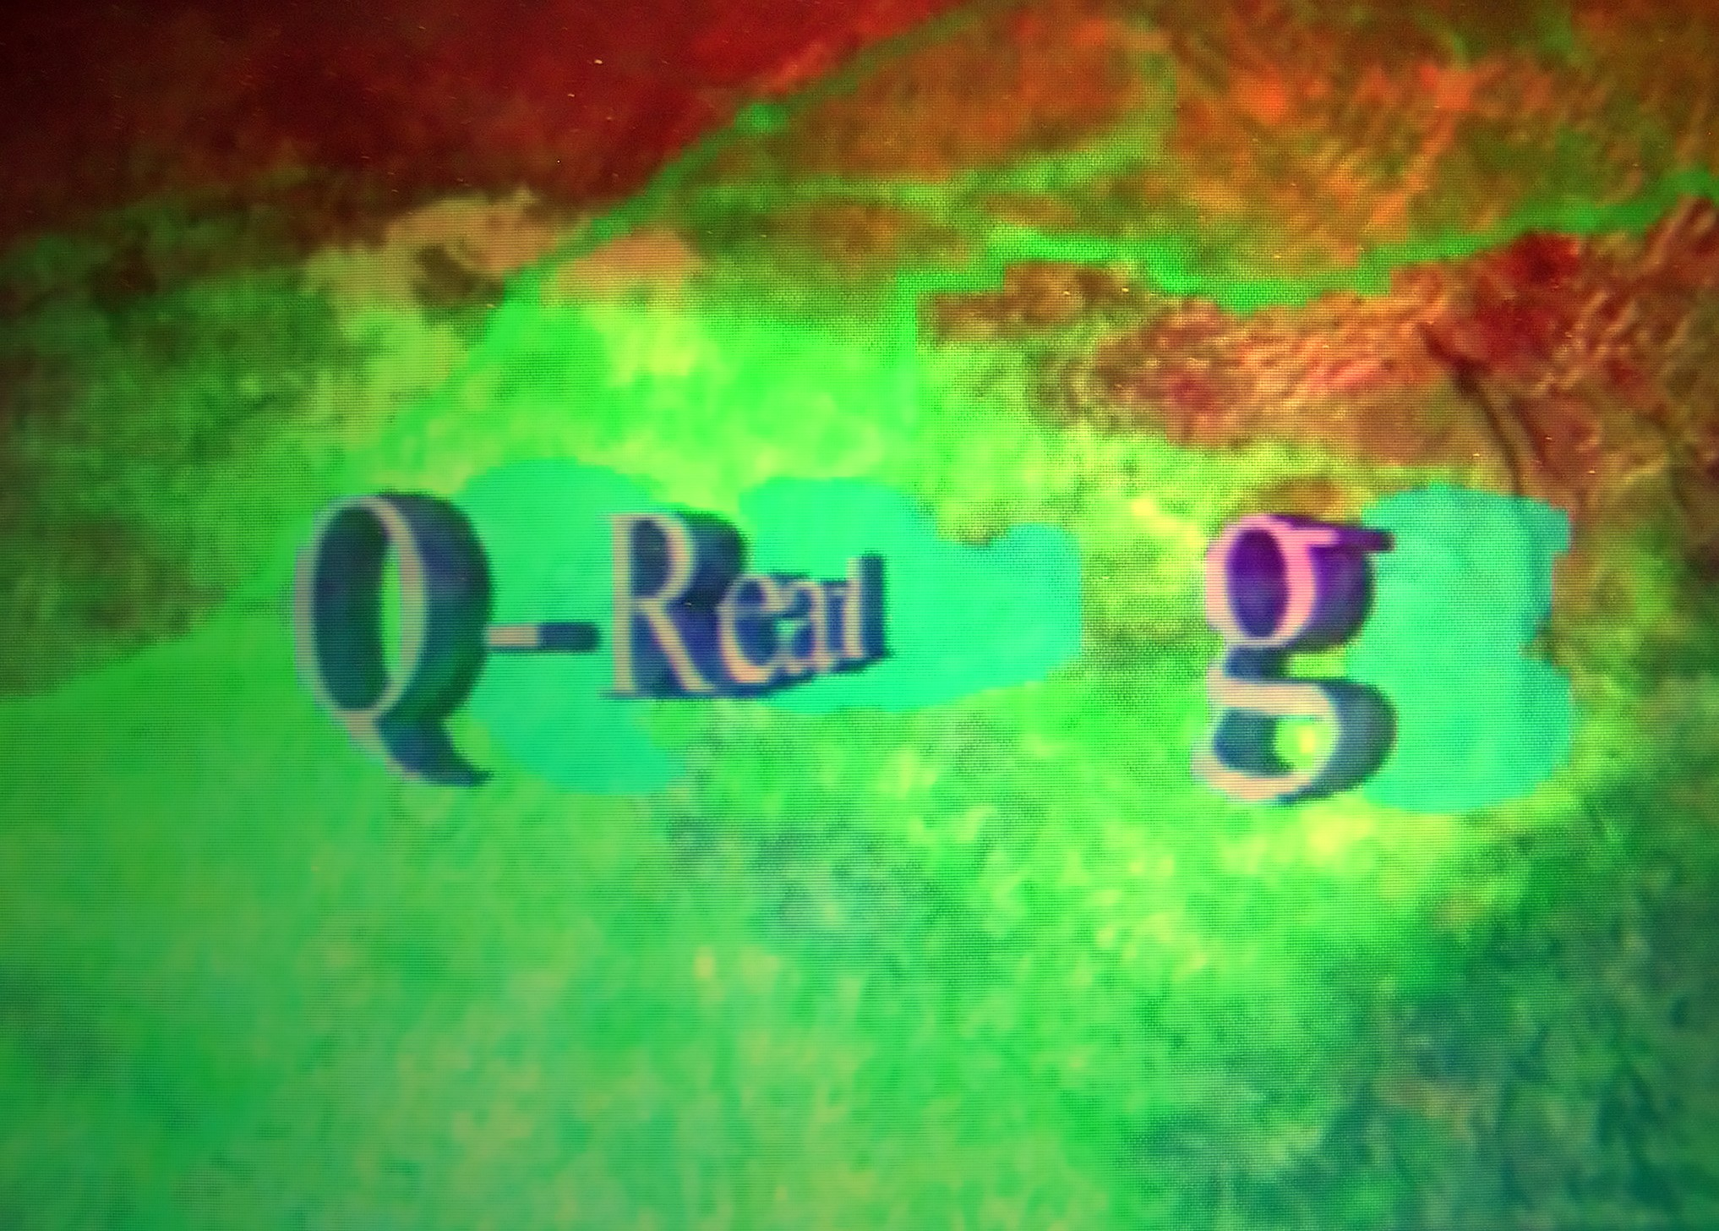

Q- Reading is an animated reading of quantum author to whom is gotten up the iS-T in action, image space-time with capacity of representation of the writing and the voice of the author who reads like performer her poem.
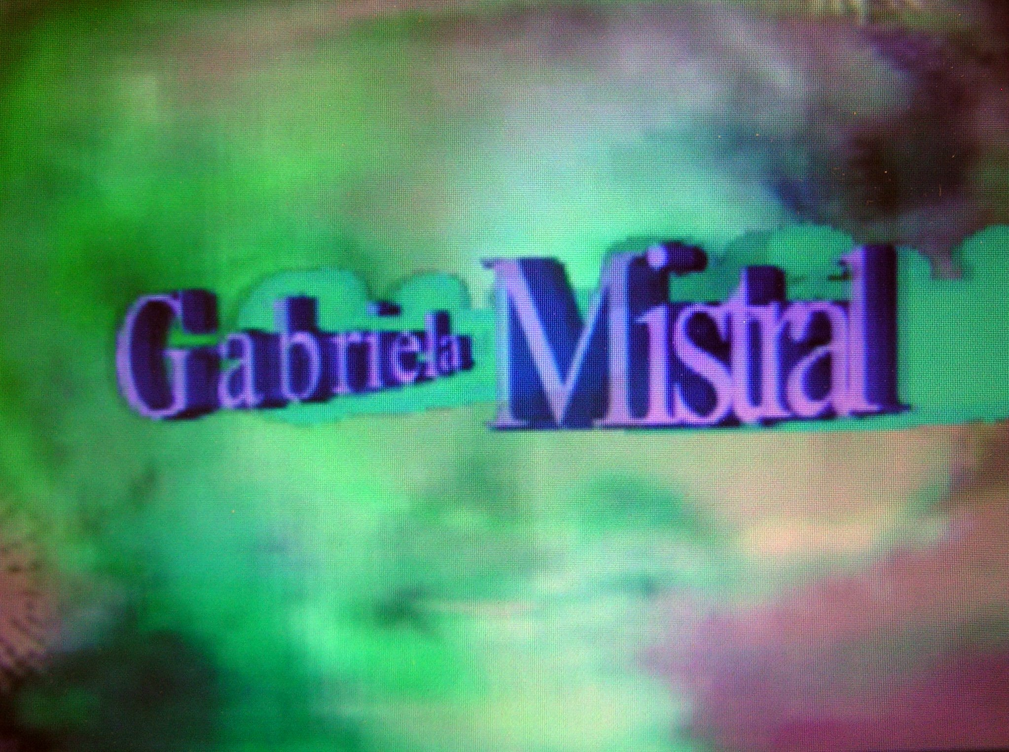
" Meciendo" is heard in original voice of Gabriela Mistral (1889 Vicuña-Chile-1957/ New the York-USA), Nobel Prize of Literature in 1945.

The reading is realised on the occasion of her 121 anniversary of her birth and its incorporation to the Q-Literary Museum Collection and a series of activities programmed around Poetic of the Quantum Age in two continents by Myriam Solar that enclose her tribute Homage with Three lessons of the Quantum Age during the 46 Congress of the Humanities & Social Sciences ACH-Concordia University, the mural and virtual exhibition in the El espacio no es un vacío, incluye todos los tiempos” Anthology with 140 poets of the world and the e-Book of Broken Jaw Press available through of Internet 28-31 May 2010, like 3 videos of the author in The Saatchi Gallery online.

The reading comprises of the global project Bodymapping Collection on performers in the S-T.-

